# USEDAD 220 Module Three Major Activity

# Michael Wood

# 03/23/2024

## Overview

Complete these steps as you work through the directions for this activity. Replace the bracketed text with a screenshot and brief explanation where indicated. Each screenshot and its explanation should be sized to approximately one-quarter of the page with the description written below the screenshot. Review the Template Screenshot Example linked in the guidelines and rubric for this assignment to see how screenshots for your assignment should look.

## Create a Database

1. In your online integrated development environment (Codio), **create a database schema** called Quantigration RMA that can hold tables.
   1. List the database name on the screen.
   2. Provide the SQL commands you ran to successfully complete this step.

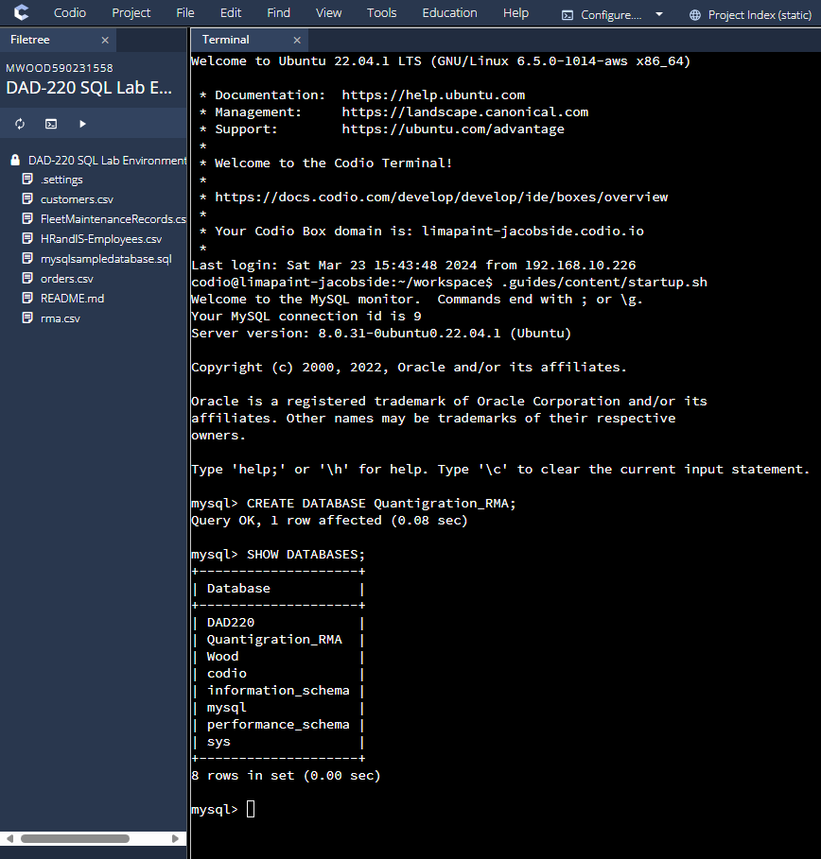

I used the CREATE DATABASE command to create the databases needed for this project.

1. Connect to the Quantigration RMA schema. **Create** the following **tables with the appropriate attributes and keys** in the Quantigration RMA database using the Quantigration RMA Entity Relationship Diagram (ERD) as a reference:
   1. A table named **Customers** to store customer information with a primary key of Customer ID
      1. Provide the SQL commands you ran against MySQL to complete this successfully in your answer:

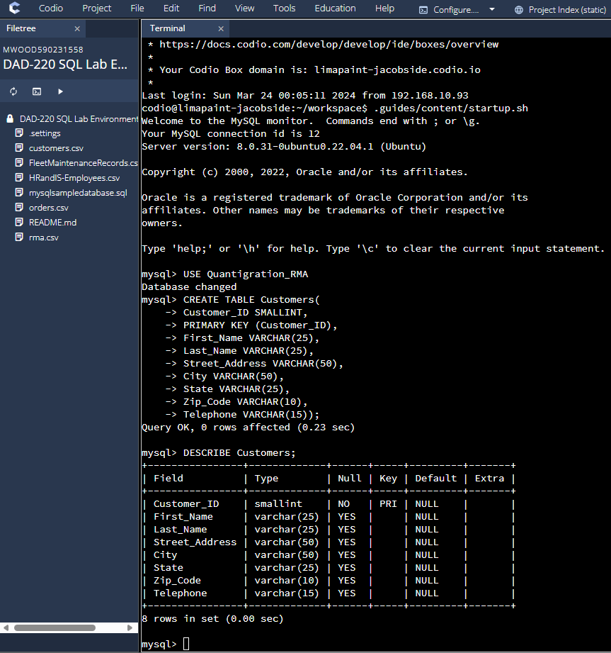

CREATE TABLE Customers( Customer_ID SMALLINT, PRIMARY KEY(Customer_ID), First_Name VARCHAR(25), Last_Name VARCHAR(25), Street_Address VARCHAR(50), City VARCHAR(50), State VARCHAR(25), Zip_Code VARCHAR(10), Telephone VARCHAR(15));

* 1. A table named **Orders** to store order information with a primary key of Order ID and foreign key of Customer ID
     1. Provide the SQL commands you ran against MySQL to successfully complete this step.

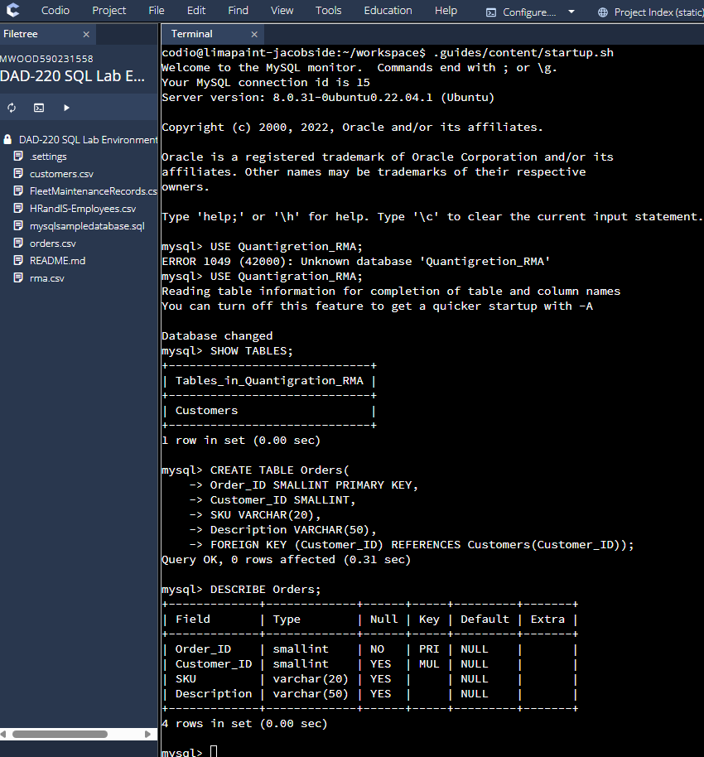

Created Table Orders (Order_ID PRIMARY KEY, Customer_ID FOREIGN KEY, SKU, and Description.

* 1. A table named **RMA** to store RMA information with a primary key of RMA ID and foreign key of Order ID
     1. Provide the SQL commands you ran against MySQL to successfully complete this step.

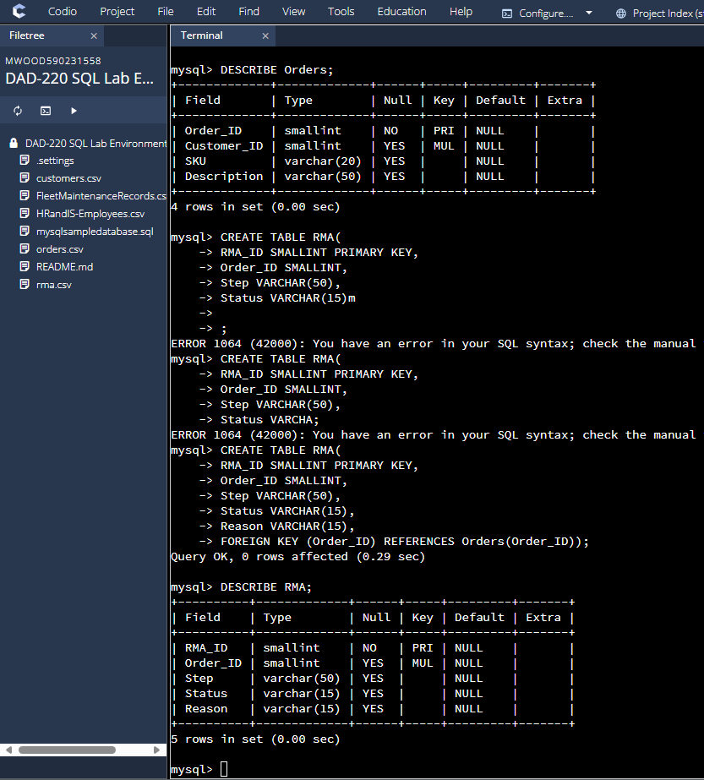

Created RMA Table with the following RMA_ID Primary Key, Order_ID Foreign Key, Step, Status, Reason.

DESCR

1. Manually **add 10 records** into the **Customers table**. For now, you can make up data. In a later assignment, you will use the CSV files provided to fill in all three tables.

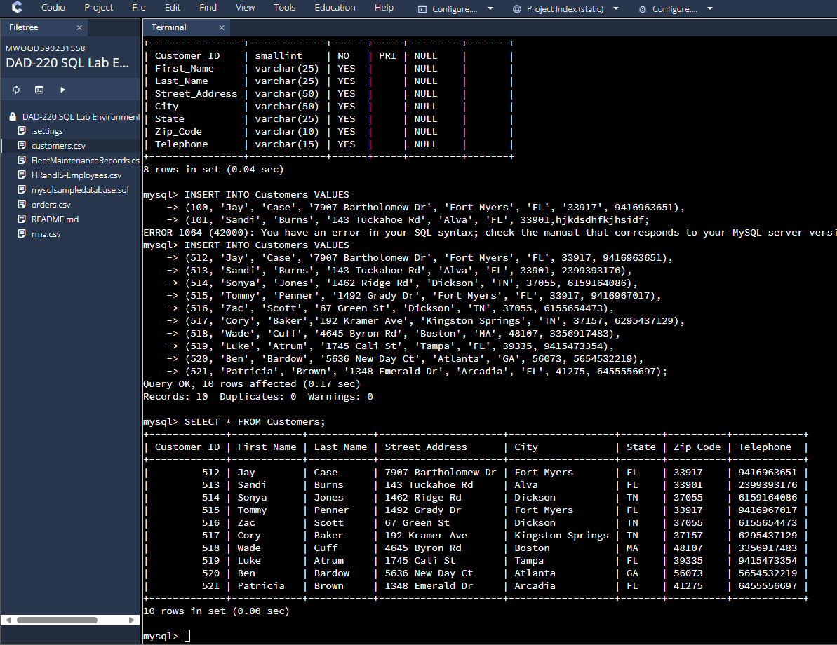

Populated Customers Table with Fake Data and customers.

1. You’ve been asked to establish a database view called Collaborators based on the Customers table. **Create** the **Collaborators View** from theexisting Customers tableby using the SQL command belowto say "Collaborators". The view should show all instances of "Customer" renamed as "Collaborator". Execute the following statements and provide one or more supporting screenshots showing the database view.
   1. The following command is partially complete. Fill in the missing information in the brackets to complete then command and run it correctly:

CREATE VIEW Collaborator AS

SELECT CustomerID AS CollaboratorID

[Enter in the correct column names from the Customer table that you want to change in the Collaborator table]

FROM Customers;

* 1. DESCRIBE Collaborator;
  2. SELECT * FROM Collaborator LIMIT 5;

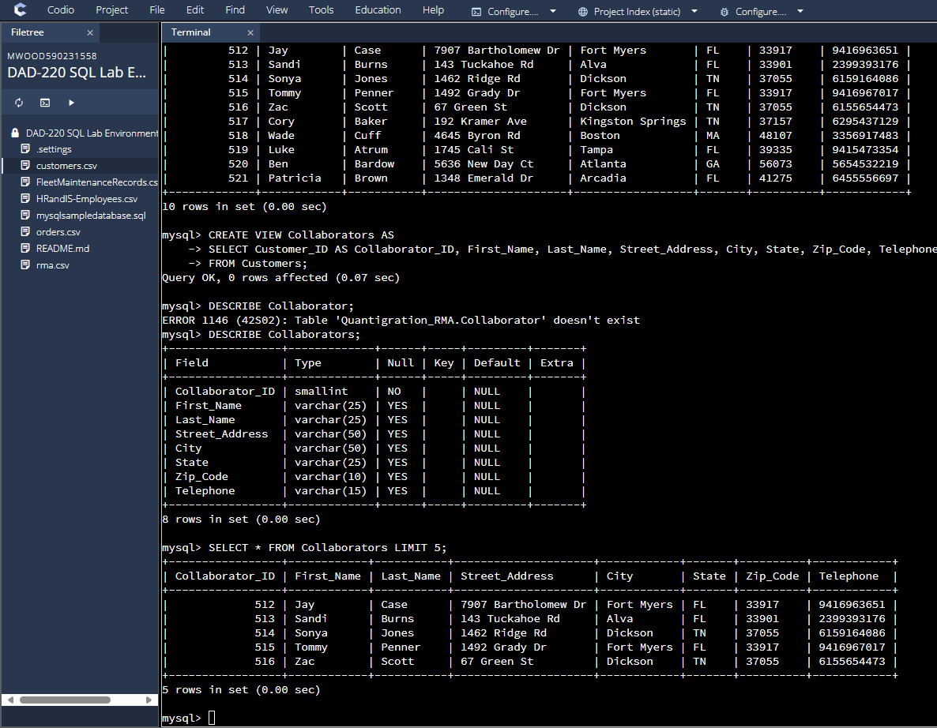

Database View Named Collaborators